Ex 1
1. What is SPA?
SPA stands for Single-Page Application. It is a web application that interacts with the user by dynamically rewriting the current page rather than loading entire new pages from the server.
Benefits of SPA
- Faster navigation and better user experience
- Less data transfer between client and server
- Easier to convert into a mobile app (using frameworks like React Native)

2. What is MPA?
MPA stands for Multi-Page Application. In MPAs, each interaction loads a new page from the server.
Differences: SPA vs MPA
Feature | SPA | MPA
Page Reload | No | Yes
Speed | Faster after first load | Slower due to full page reload
SEO Support | Less optimal | Better
Example | Gmail, Facebook | Amazon, Flipkart

3. What is React?
React is a JavaScript library developed by Facebook for building user interfaces, especially SPAs. It helps create reusable UI components.

4. What is Virtual DOM?
The Virtual DOM is a lightweight copy of the real DOM. React uses it to:
- Detect changes
- Minimize direct DOM manipulation
- Update only what’s necessary in the real DOM

5. Features of React
- Component-based
- Virtual DOM
- Declarative UI
- Unidirectional Data Flow
- Fast Rendering
- JSX Syntax

Code :
function App() {
return (
<div style={{ display: 'flex', justifyContent: 'center', alignItems: 'center', height: '100vh' }}>
<h1>Welcome to the first session of React</h1>
</div>
);
}

export default App;

Output :
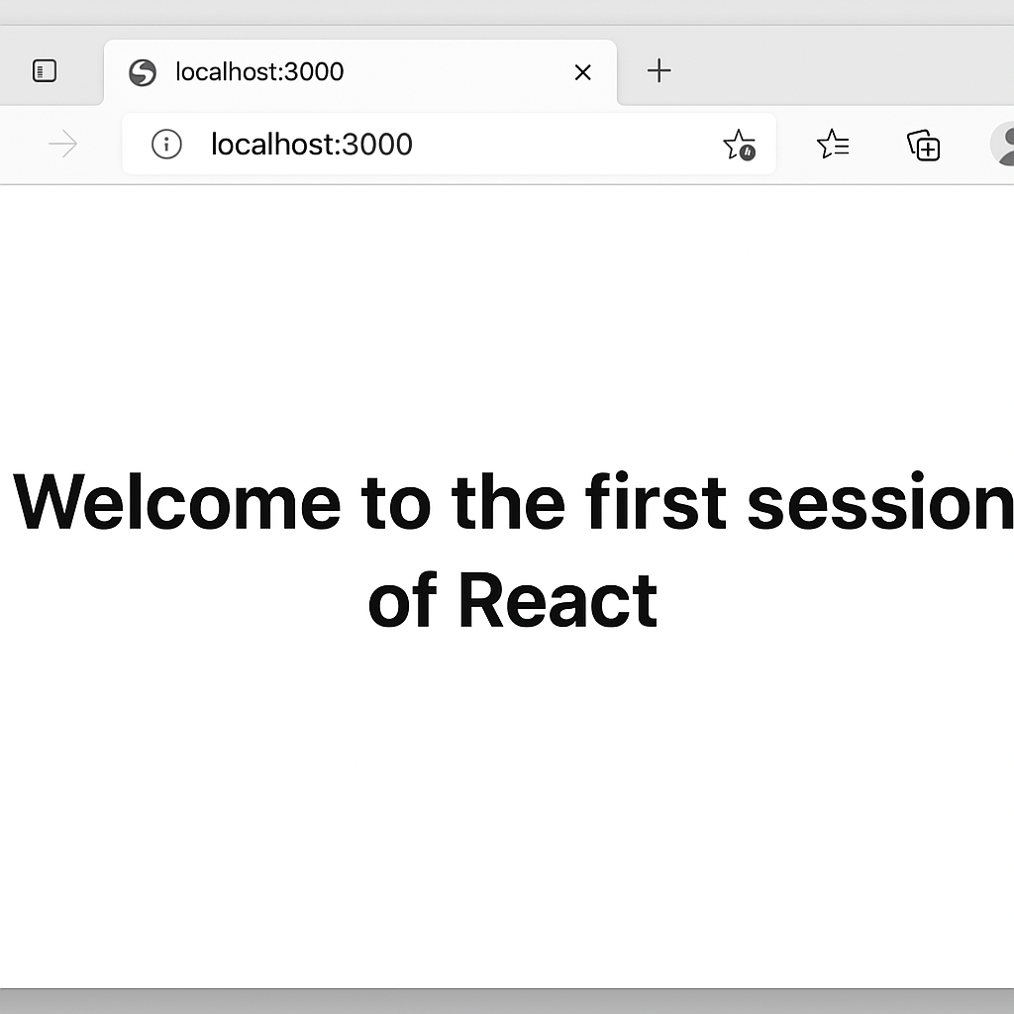

Ex 2 :
What are React Components?
React Components are reusable blocks of code used to build UI elements.
Components vs JavaScript Functions
Feature | React Component | JS Function
Purpose | UI building block | General logic
Returns | JSX / HTML | Data / Value
Lifecycle methods | Yes (class components) | No
Types of Components
- Class Components
- Function Components
Class Component
Uses class and must include:
- A constructor (optional)
- A render() method to return JSX
Function Component
Simpler. A JavaScript function that returns JSX.
Code :
App.js
import React from 'react';
import Home from './Components/Home';
import About from './Components/About';
import Contact from './Components/Contact';

function App() {
return (
<div style={{ textAlign: 'center', marginTop: '50px' }}>
<Home />
<About />
<Contact />
</div>
);
}

export default App;
About.js
import React, { Component } from 'react';

class About extends Component {
render() {
return (
<h2>Welcome to the About page of the Student Management Portal</h2>
);
}
}

export default About;
Contact.js
import React, { Component } from 'react';

class Contact extends Component {
render() {
return (
<h2>Welcome to the Contact page of the Student Management Portal</h2>
);
}
}

export default Contact;
Home.js
import React, { Component } from 'react';

class Home extends Component {
render() {
return (
<h2>Welcome to the Home page of Student Management Portal</h2>
);
}
}

export default Home;
Output :
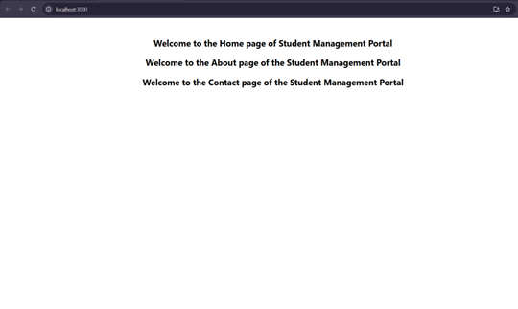

Ex 3 :
CalculateScore.js
import React from 'react';
import '../Stylesheets/mystyle.css';

function CalculateScore() {
const name = "JONES J";
const school = "KRCE";
const total = 430;
const goal = 500;
const average = (total / goal) * 100;

return (
<div className="score-container">
<h1>Student Score Calculator</h1>
<p><strong>Name:</strong> {name}</p>
<p><strong>School:</strong> {school}</p>
<p><strong>Total Marks:</strong> {total}</p>
<p><strong>Goal Marks:</strong> {goal}</p>
<p><strong>Average Score:</strong> {average.toFixed(2)}%</p>
</div>
);
}

export default CalculateScore;
mystyle.css
.score-container {
text-align: center;
margin-top: 50px;
background-color: #f5f5f5;
padding: 40px;
border-radius: 10px;
font-family: Arial, sans-serif;
box-shadow: 0px 0px 10px #ccc;
}

.score-container h1 {
color: #2b3a55;
}

.score-container p {
font-size: 18px;
color: #333;
margin: 8px 0;
}
App.js
import React from 'react';
import CalculateScore from './Components/CalculateScore';

function App() {
return (
<div>
<CalculateScore />
</div>
);
}

export default App;

Output :
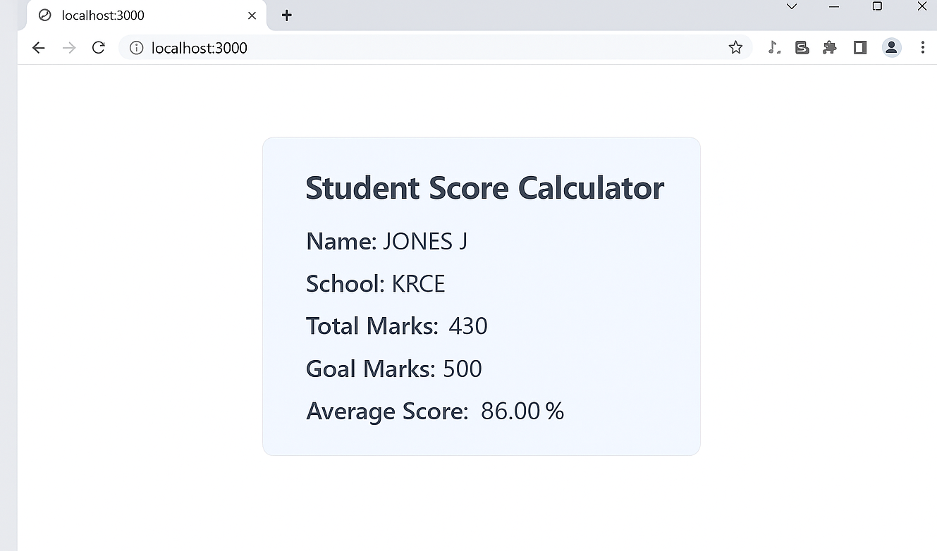

Ex 4 :
Post.js
import React from 'react';

class Post extends React.Component {
render() {
return (
<div style={{ marginBottom: '1rem', padding: '1rem', border: '1px solid #ccc' }}>
<h3>{this.props.title}</h3>
<p>{this.props.body}</p>
</div>
);
}
}

export default Post;
Posts.js
import React, { Component } from 'react';
import Post from './Post';

class Posts extends Component {
constructor(props) {
super(props);
this.state = {
posts: [],
hasError: false,
};
}

loadPosts = () => {
fetch('https://jsonplaceholder.typicode.com/posts')
.then((response) => response.json())
.then((data) => this.setState({ posts: data }))
.catch((err) => {
this.setState({ hasError: true });
console.error('Error loading posts:', err);
});
};

componentDidMount() {
this.loadPosts();
}

componentDidCatch(error, info) {
alert('Something went wrong: ' + error);
console.error('Error details:', info);
}

render() {
return (
<div>
<h2>Blog Posts</h2>
{this.state.posts.map((post) => (
<Post key={post.id} title={post.title} body={post.body} />
))}
</div>
);
}
}

export default Posts;

App.js
import React from 'react';
import Posts from './Posts';

function App() {
return (
<div className="App" style={{ padding: '2rem' }}>
<h1>Welcome to BlogApp</h1>
<Posts />
</div>
);
}

export default App;
Output :
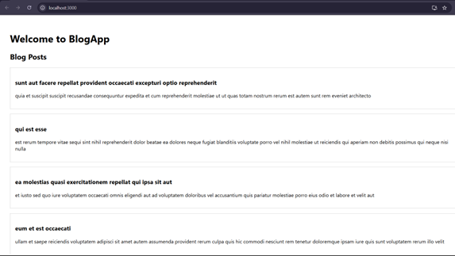

Ex : 5
CohortDetails.module.css
.box {
width: 300px;
display: inline-block;
margin: 10px;
padding: 10px 20px;
border: 1px solid black;
border-radius: 10px;
}
dt {
font-weight: 500;
}
CohortDetails.js
import React from 'react';
import styles from './CohortDetails.module.css';
function CohortDetails({ name, trainer, status }) {
const titleStyle = {
color: status === 'ongoing' ? 'green' : 'blue'
};
return (
<div className={styles.box}>
<h3 style={titleStyle}>{name}</h3>
<dl>
<dt>Trainer:</dt>
<dd>{trainer}</dd>
<dt>Status:</dt>
<dd>{status}</dd>
</dl>
</div>
);
}
export default CohortDetails;
App.js
import React from 'react';
import CohortDetails from './CohortDetails';
function App() {
return (
<div style={{ padding: '2rem' }}>
<h1>Cohort Dashboard</h1>
<CohortDetails name="React Bootcamp" trainer="John" status="ongoing" />
<CohortDetails name="Angular Sprint" trainer="Sara" status="completed" />
</div>
);
}
export default App;
Output :
